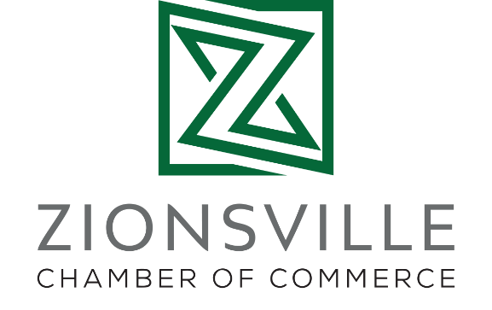
The Zionsville RISE Foundation
The Zionsville RISE Foundation, a 501(c)(3), was established in 2021 as the new Foundation arm of the Zionsville Chamber. The Foundation aims to support entrepreneurs and leaders in the community through education and workforce development whose purpose compliments the work of the Zionsville Chamber of Commerce.
RISE – Reveal Ideas, Shape Endeavors – centers around three tenants: encourage environmental sustainability, enrich our community through diversity, equity & inclusion and foster workforce development through education. These pillars guide us in the development of programs and initiatives, exploring grant opportunities and in providing leadership for these areas of focus.
We received our official IRS designation paperwork in October of 2021 and have already launched a STEM education project, applied for a large state grant, and started planning for a community-wide learning program. We are actively seeking community partnerships and cultivating strategic connections to enhance our opportunities for success.
One early accomplishment includes the STEMz Project, a free STEM education program for students in 7th-12th grades with the first educational session held in March 2022. The program will conclude in June with a race after the students build the circuitry, chassis and assemble an electric micro-kart.
Also in March, we received a license to host the first TEDx Zionsville, an independent TED event in Zionsville, Indiana. We became eligible to apply to host the event after attending a TEDWomen conference in December 2021. We plan to host the TEDx Zionsville event in Fall 2022.
The Zionsville RISE Foundation is looking to position itself as the long-term partner in development initiatives for the business community. In creating this new organization, we can explore a greater stratification of funding opportunities, develop innovative partnerships and expand our impact within the Zionsville business community.

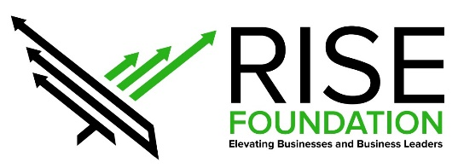

https://www.zionsvillerise.com

