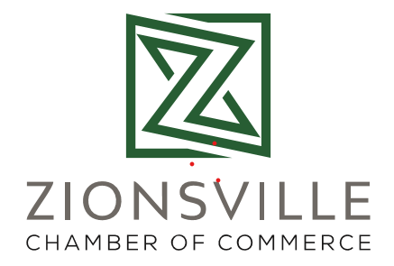
Working For You Social Media Sponsorships
In 2020 we took to social media as the vehicle available to showcase our members at the lowest barrier to entry and the most readily accessible. We used Facebook and LinkedIn with some frequency, with Instagram a distant afterthought. We hosted a Google seminar in January 2020 and learned that video content was retained and viewed 80% better than text alone. When the pandemic closed businesses we took to social media with renewed energy.
We started early in 2020 working with a member videographer creating a video series entitled “Working For You”- a dirty jobs style series of videos that were created to stir interest in parts of our membership people rarely see. The videos introduced non-profits like a equine therapy program to our viewers while the Executive Director of the ZCoC fed horses and mucked stalls. We packed masks to send to remote indigenous villages with 120Water. We built wooden items with a home based business. We crafted with individuals with special needs. We packed meals for the needy during the closures. We went into a church where over 1000 bats were being remediated with a pest company. Coupled with our other social media efforts we became a chamber that people wanted to watch.
And watch they did. Our visibility on social media went from 250,000 impressions in 2019 to over TWO MILLION in 2020. This increase represents people seeing, reacting to and utilizing the businesses in our membership. By having this social media visibility we were able to create an additional revenue stream in 2021 with sponsorships of video series highlighting segments of our membership and segments of our postings. We hoped that this new revenue stream would generate $10,000 in 2021. As of April 2021 we are already at $22,500 in sponsorships. Our social media viewership and response outperforms chambers that are many times larger than a small, local chamber. We are proud of this effort and so are our members.
Examples of Working for You Videos:
https://www.facebook.com/ZvilleChamber/posts/10157067645957274 (crafts)
https://www.youtube.com/watch?v=4hfoZkonPuQ (bats)
https://www.facebook.com/ZvilleChamber/posts/10156651758372274 (horses)

