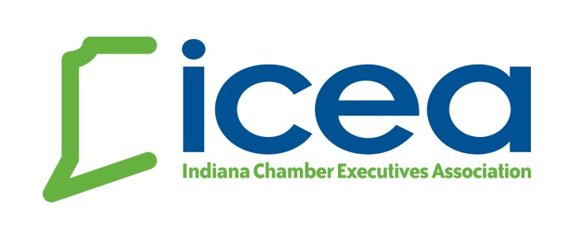
Hoosier Chamber Academy Candidate Application
What is the Academy? The Hoosier Chamber Academy is a series of high quality programs on chamber topic “essentials” geared for today’s chamber execs and professional staff. Topics addressed include: Chamber Law; Marketing & Communications; Board Development; Membership; Non-Dues Revenue; and Advocacy. Class members will work together for a final class project to identify and solve a problem within our professional industry.
Academy participants share resources from individual chambers to create a class tool-kit accessible by fellow classmates. The Hoosier Chamber Academy has become the leading training program in Indiana totally devoted to chamber professionals wanting to fine-tune basic skills. Class size is limited to 20 professionals. Return this application to shelli@iceaonline.com for consideration to be included in the next Hoosier Chamber Academy Class.
Academy Fee: $225 for the series for ICEA member chambers
Tentative Schedule for 2024: April 19, May 31 and June 12
The 2024 Academy will be held in person at MADE@Plainfield in Plainfield, Indiana with the final class being held pre-conference in Madison.
Classes begin at 10:30 a.m. EST and adjourn at 3:00 p.m. EST for each session.

Applicant Information
(please e-mail completed application to info@iceaonline.com)
Name:
Chamber:
Title:
E-Mail:
How long have you been in the Chamber profession?
What do you hope to gain from the Academy experience?
Dietary restrictions?

